[CEN 323] Computer Organization & Assembly Language
Lab 9 Journal

Name : Fatima Asad
Enrollment Number: 01-135232-020

Lab Deliverables (submission guideline)

Create a folder named after your enrollment number and add the following files:
  - Create a folder named YourRollNumber_Lab1 containing:
- .asm files of the three practice tasks.
- Add full screen screenshots of the code and output in this word file.
  - Zip the Folder and upload it to LMS.

Lab Task

Task 1:
Code (TEXT):
.model small
.stack 100h

.data
arr dw 1,2,3,4,5,6,7,8,9,10

.code
main proc

mov ax, @data
mov ds, ax

mov cx, 10
mov bx, 0

loop1:
mov ax, arr[bx]
push ax
add bx, 2
loop loop1

mov cx, 10
mov bx, 0

loop2:
pop ax
mov arr[bx],ax
add bx,2
loop loop2

mov ah, 4ch
int 21h

main endp
end main

Screenshot (CODE):
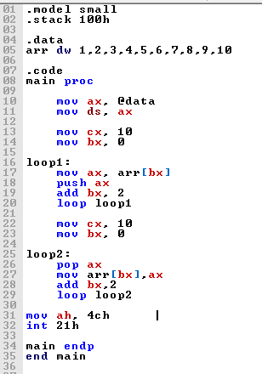

Screenshot (OUTPUT):
Array:
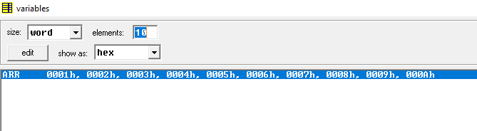
Array in reverse:
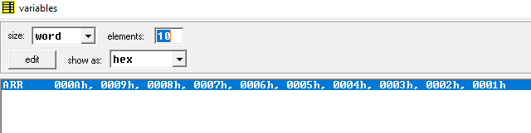

Task 2:
Code (TEXT):
.model small
.stack 100h

.data
arr dw 10 dup(?)
count dw 0

msg1 db 'Enter 10 numbers: $'
msg2 db 13,10,'Even numbers are: $'

.code
main proc
mov ax, @data
mov ds, ax

mov dx, offset msg1
mov ah, 09h
int 21h

mov cx, 10
mov si, 0
mov count, 0

loop1:
mov ah, 01h
int 21h

sub al, '0'
mov ah, 0

mov arr[si], ax

mov ax, arr[si]
mov bl, 2
div bl

cmp ah, 0
jne loop2

mov ax, arr[si]
push ax
inc count

loop2:
add si, 2
loop loop1

mov dx, offset msg2
mov ah, 09h
int 21h

mov cx, count

loop3:
pop ax

add al, '0'
mov dl, al
mov ah, 02h
int 21h

mov dl, ' '
mov ah, 02h
int 21h

loop loop3

mov ah, 4Ch
int 21h

main endp
end main

Screenshot (CODE):
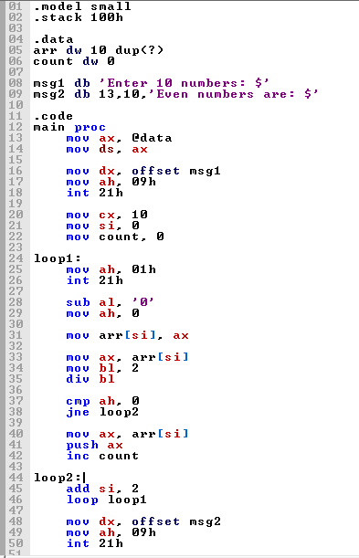

Screenshot (OUTPUT):
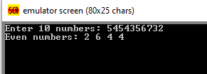

Task 3:
Code (TEXT):
.model small
.stack 100h

.data
max dw 0
count dw 0

msg1 db 'Enter a number (press enter to stop): $'
msg2 db 13,10,'MAX value is: $'

.code
main proc

mov ax, @data
mov ds, ax
mov ah, 09h
lea dx, msg1
int 21h

loop1:

mov ah, 01h
int 21h

cmp al, 13
je loop2

sub al, '0'
mov ah, 0

push ax
inc count

jmp loop1

loop2:

mov ah, 09h
lea dx, msg2
int 21h

mov cx, count

loop3:
pop bx

cmp max, bx
jge SKIP

mov max, bx

SKIP:
loop loop3
mov ax, max
add al, '0'
mov dl, al

mov ah, 02h
int 21h

mov ah, 4Ch
int 21h

main endp
end main

Screenshot (CODE):
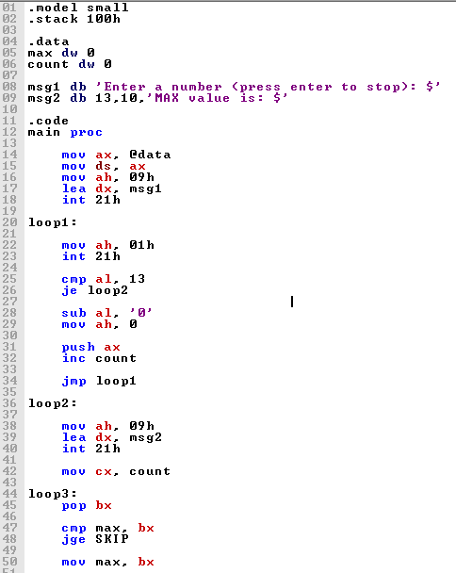

Screenshot (OUTPUT):

